Title of the article for Microsoft Office Word
Author1 Name ª , Author2 Name ^{a,b} ,

a. Address1, City, Zip code, Country
b. Address2, City, Zip code, Country

*Corresponding author: name@email.address (Author1)

[Abstract]
A short abstract should open the paper. A concise and factual abstract is required. The abstract should state briefly the purpose of the research, the principal results and major conclusions. An abstract is often presented separately from the article, so it must be able to stand alone. For this reason, References should be avoided, but if essential, then cite the author(s) and year(s). The author should try to avoid equation in abstract because of the text format.

[Key words]
Keyword1, Keyword2, Keyword3, Keyword4, Keyword5

[Highlights]
- Highlight1 within 120 characters, including spaces, per bullet point.
- Highlight2 within 120 characters, including spaces, per bullet point.
- Highlight3 within 120 characters, including spaces, per bullet point.

Wind tunnel test is an important means to obtain complex flow characteristics. The load measurement in the existing wind tunnel test mainly includes direct force measurement and surface pressure measurement. The wind tunnel scale model of the aircraft is therefore divided into two types: force measurement model [1] and pressure measurement model [2–4].
$A=πr^{2},$ (1)
$y=ϕx,$ (2)

where r is the radius of the circle. In Eqs. (1) and (2), $ψ$ is the sparse basis function obtained by……….
Brunton et al. [11] proposed a method based on compressed ……...
The algorithm framework is shown in Fig. 1. The research content is mainly divided into the following four aspects. (1) Use computational fluid dynamics (CFD) to calculate the pressure distribution of the same airfoil in various states (NACA0012 airfoil) and variable airfoils in the same state under the condition of subsonic speed. (2) Construct the sparse basis function of the pressure field based on the proper orthogonal decomposition (POD) technology. (3) Selection of pressure measuring point position on airfoil surface: the best measuring point position is obtained through training through particle swarm optimization (PSO) algorithm. (4) Flow field reconstruction based on compressed sensing technology.
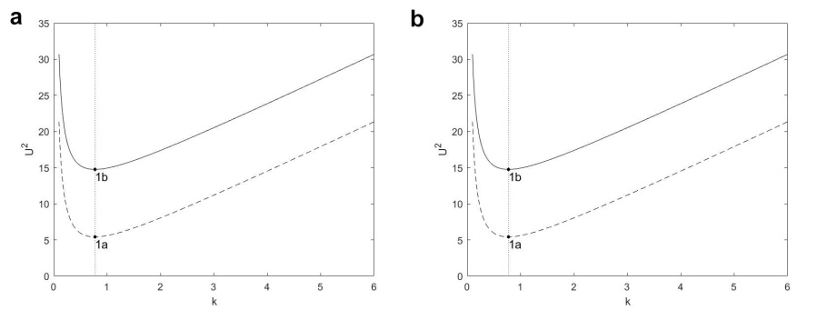
Fig. 1 a Photos and scales in mm of one of the axisymmetric bottom-heavy rods and its assembly parts used in the experiments. b Example of trajectory of a bottom-heavy rod reconstructed.
In order to make the results more universal, Table 1 compares the reconstruction errors of measuring points with 0%, 1%, and 1.5% noise.
Table 1: Error comparison with noise
Noise level | 0 | 1% | 1.5%
MSE | 0.0200 | 0.0218 | 0.0235
error | 0.0124 | 0.0160 | 0.0193
Acknowledgements
This work was supported by the foundation of …..

References
- Y.Q. Zheng, Force measuring experiment for the scale model of WDPSS in low-speed wind tunnel, J. Huaqiao Uni. Nat. Sci. Mar. 2 (2009) 119–122.
- B.R. Noack, M. Morzynski, G. Tadmor, Reduced-Order Modelling for Flow Control, Springer Vienna, 2011.
- S.L. Brunton, B.R. Noack, Closed-loop turbulence control: progress and challenges, Applied Mechanics Reviews 67 (2015) 050801.
- S. Sankaran, M.E. Moghadam, A.M. Kahn, et al., Patient-specific multiscale modeling of blood flow for coronary artery bypass graft surgery, Ann. Biomed. Eng 40 (2012) 2228.

Figures:
Fig. 1 a Photos and scales in mm of one of the axisymmetric bottom-heavy rods and its assembly parts used in the experiments. b Example of trajectory of a bottom-heavy rod reconstructed.

Table:
Table 1: Error comparison with noise

